**Group 14**

**REQUIREMENT ANALYSIS &**

**DESIGN DOCUMENT**

.

**Content**

Acknowledgment

1.Introduction

* Domain description
* Current system & Its limitations
* Objectives & Goals
* Scope of the Project
* Assumptions, Constraints & Limitations

2.Feasibility Study

3.Requirements

* Stakeholders
* Use cases and Usecase diagrams
* Functional Requirements
* Non- Functional Requirements

4. Proposed system’s Architecture

* Components and their responsibilities
* Component interactions

5.System’s Design

* Class diagrams
* Sequence diagrams

6.User Interface Flow Diagram

**Acknowledgment**

In preparing the Requirement Analysis & Design Document, we had to take the help and guidance of some respected persons, who deserve our greatest gratitude. We would like to show our gratitude to our supervisor Dr. D. N. Ranasinghe for giving us a good guideline for this project.

We would also like to extend our gratitude to our mentor, Miss T.T. Kaluarachchi. We would also like to expand our deepest gratitude to all those who have directly and indirectly guided us in writing this Report.



1. **Introduction**

1.1. Domain description

* Project Title : Process Management System
* Alternative Title : PMS
* Client : Chief Engineer of Maharagama Urban Council

Maharagama Urban Council Does lots of Works in multiple Departments.

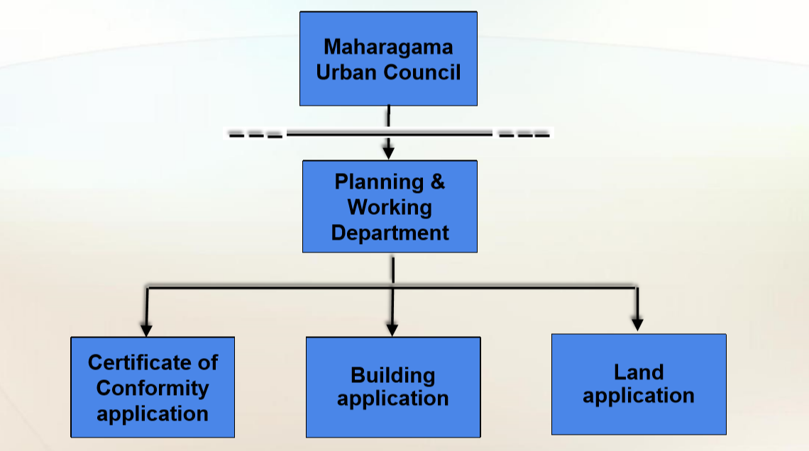

In every week there are so many people come to Work and Planning Divison of Maharagama Urban Council and waiting in the queues. So our client ask to reduce this delay by introduce an Automated system to the current process. After the implementing this system the delay will reduce and there will be less paper work in the process.

1.2. Current Process & Its Limitations

Currently Planning and Working Department of Maharagama Urban Council is using a manual method in their department.

Reasons for Automations,

* Increasing number of Files to Approve: Day by day there are so many applications arrive without completing previous application in the queue.
* Consuming a long time duration to process a single file - Since it’s a manual and complex process it consume some serious time to complete a single application file.
* Possibility of damaging and losing files during the process - Since its a manual process those things are inevitable.
* The Department has to approved about 50 applications per week.

Constraints & Limitations

* Since recruit a new employee for Administer position is a costly method, we decide to select Chief Engineer as the administrator of the system.
* Giving those privileges to respective Actors of the system and limits/prevents the access of unauthorized people.
* Since those staff members never used such a system , we may need to guide them and train them in initial stages.

1.3. Objectives & Goals

After implementation the new system,

* Reduce paper work because all the files going to be handle by the system.
* Increase the efficiency of the process.
* Applicant can inquire current status of the application process, by requesting it from Management Assistant.
* Important notifications going to be received by the applicant as a SMS or email.
* Maintain soft copy of documents (backup purpose); this objective will be reached only if time permits.
* Provide services in a cost effective manner.
* Provide ability to quickly search for and retrieve administrative information.
* Provide service to all stakeholders in minimum time

1.4. Scope of the Project

Maharagama Urban Council divides into several departments and divisions. So we have selected “Plan and Working Division’s” , Building Approval part to make the Automation. So the Processes which is in BLUE rectangles will be automated by PMS.

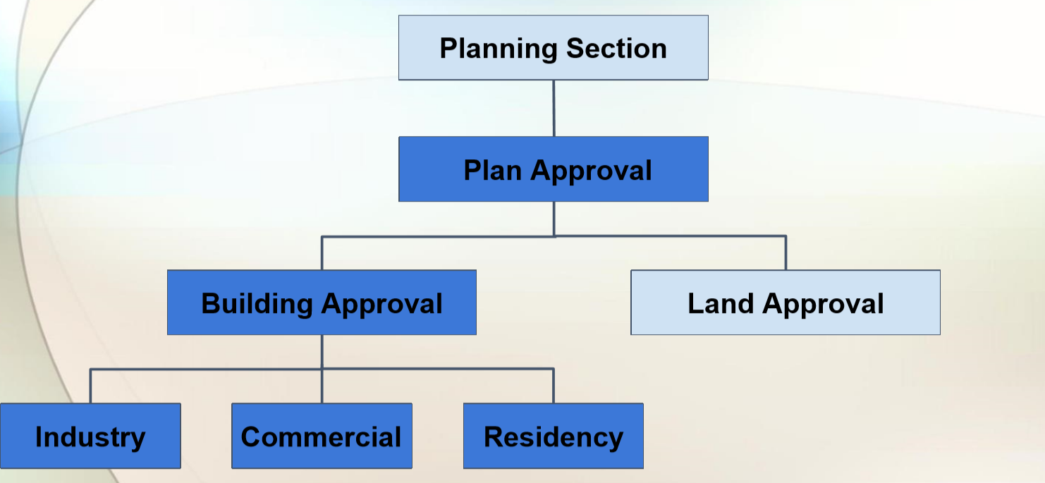

1.5. Assumptions, Constraints & Limitations

* We assume that our client will establish the required LAN (Local Area Network) before implementing the Process Management System.
* We assume that the Urban Council Staff could be trained completely before implementing the system. We wish to motivate them to get the required computer training quickly.
* Urban Council staff will continue to use the existing manual system along with Process Management System after its implementation.

1. **Feasibility Study**

A feasibility study is an analysis of how successfully a project can be completed, accounting for factors that affect it such as economic, technological, legal and scheduling factors. Project managers use feasibility studies to determine potential positive and negative outcomes of a project before investing a considerable amount of time and money into it.

Fact Finding Methods

● Site Visit.

● Discussion(Board meeting) with a chief engineer and the staffs.

● Sampling of existing documentation.

● Observation of work environment.

**2.1. Operational Feasibility**

The Automated project management system which is ready to provide reports system which will be useful for the staff members in the Urban Council**.**

As we are going to create user friendly designs, user will be able use our application without any hesitation.

* It is not necessary to have much IT knowledge to operate this. As we are giving user friendly interfaces to the users of the system, it will make easy to update database by entering their data.
* All files will be handled from the system until the final approval.
* Consider all the requested requirements of the client.

**2.2. Cultural Feasibility**

In Maharagama Urban Council**,** since currently most of the processes are done manually. Lot of time and effort is needed to complete a particular task inside the department because the whole department is with a mess full of files and other documentation.

Currently Applicants are suffering because of the delay in the process and the new system will make the process efficient. Currently the staffs are not dealing with computers and following manual procedures but after our group members explain about the advantages of an automated system the Staff members willing to adjust themselves for it, because the Manual System is more Complex and they find it very difficult to handle the large number of files manually.

**2.3. Technical Feasibility**

Today, technology is broad and can be easily obtained.Consequently technical feasibility looks at what is practical and reasonable.

We are going to develop process management system. We wish to use Java SE for the development purpose of the system.The Database Management System which we are going to use is MySQL and the report generation tool will be Jasper Reports.

The technologies mentioned above are free and open source.

And also these technologies are easy to learn and use. There are many resources available to take advices and help and also to solve problems in these technologies, so that the learning curve will not impact the schedule of of the project at all .Few of our Group members have already started to learn the above languages because some of those languages are new to them and few of them are fluent in those languages. If we identify new suitable technologies, we might use those technologies instead of technologies we have mentioned.

**2.4. Economic Feasibility**

In the developing process we use opensource development techniques and all the coding will be done by our group members not by any hired contract programmers, so it won’t costs from the coding aspect . No profit is expected by the members of our group from the implementation of this system.

As we are using free and open source to develop the system there is Less financial costs. During the implementation, Host computers, Server computer and LAN connection Components will add some additional cost. However, we wish to use our own computers and laptops so that we can reduce those costs and the remaining costs will be funded by our group members.

**2.5. Legal Feasibility**

Functional requirements are legal since there is no any issues regarding copyright of the software and technologies, As we are using free and open source software for development.

Data collected will be store in a secured database and server is secured. Only authorised parties not third parties can access information and system.

Privacy and confidentiality of information will be protected by our group members.

System development by our group members during academic period. No contract programmers/employees are hired for this process. so there will not be any issues regarding ownership of code

**2.6. Schedule Feasibility**

This schedule feasibility includes the schedules of our proposed system.

Holidays and weekends are considered as working days and we are planning to work on holidays and weekends as well and we include them into the project schedule.

We have to submit our project before December 2017. As we have a mandatory deadline we don’t have any alternative schedules except one realistic estimated time frame. According to the future plan of our group and the details we have gathered from previous projects we hope to finish our project by the end of December 2017.

1. **Requirements**

**3.1. Stakeholders**

Counter Clerk, Management Assistant, Technical Officer, Subject Clerk, Chief Engineer and the Secretary are the Stakeholders of this system.

**3.2. System Use Cases and Use Case diagram**

* **System Use Cases**

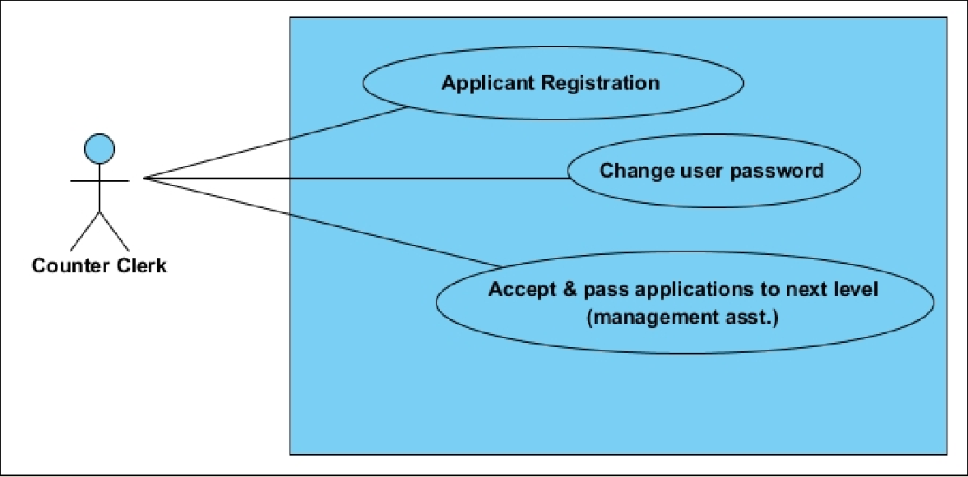

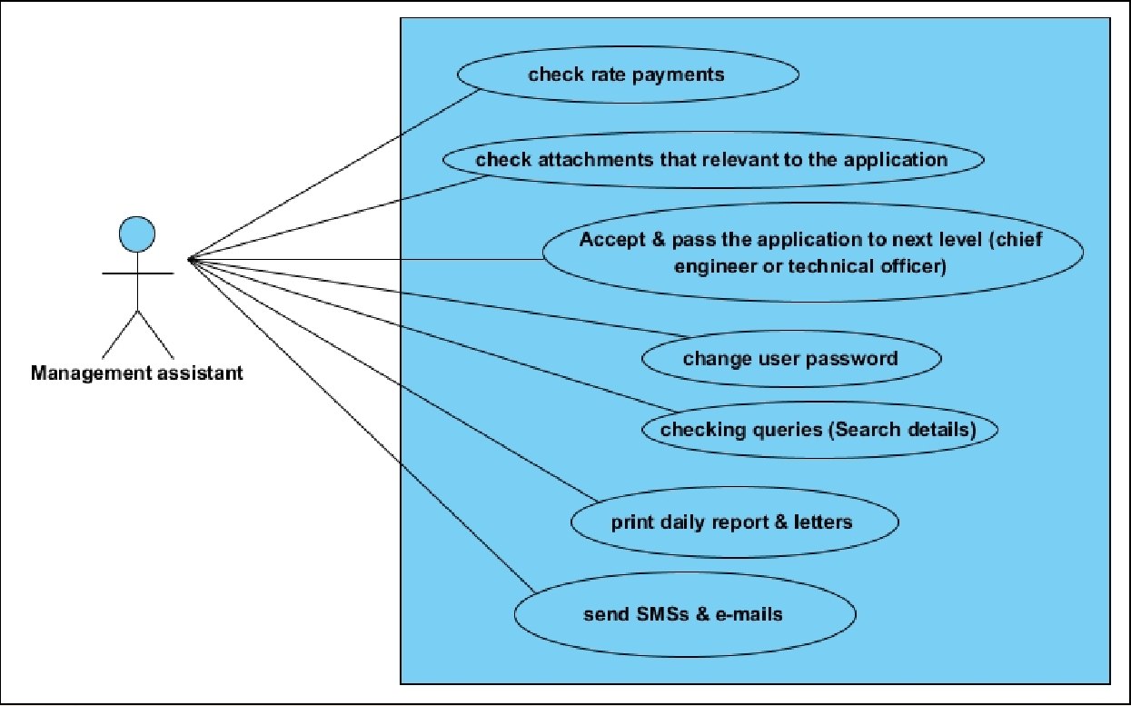

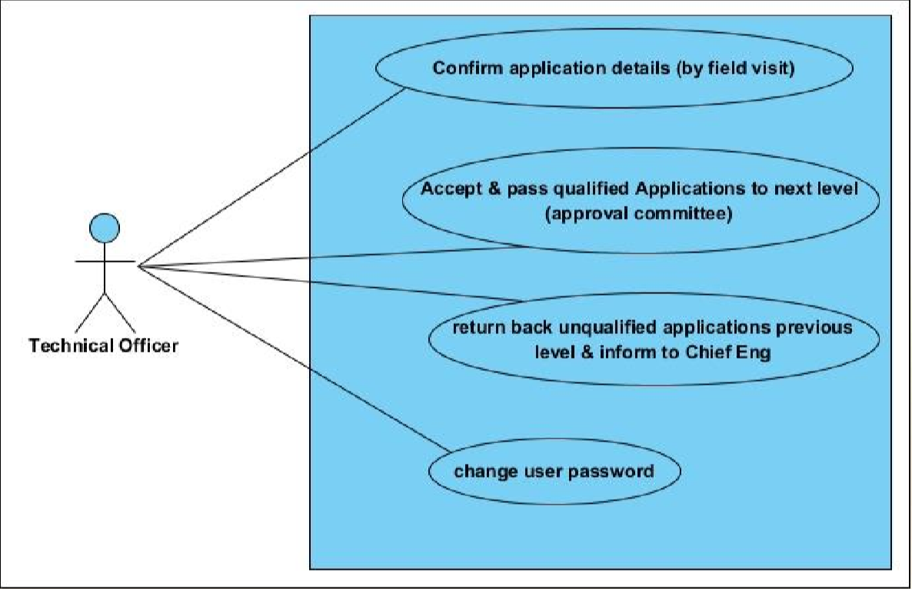

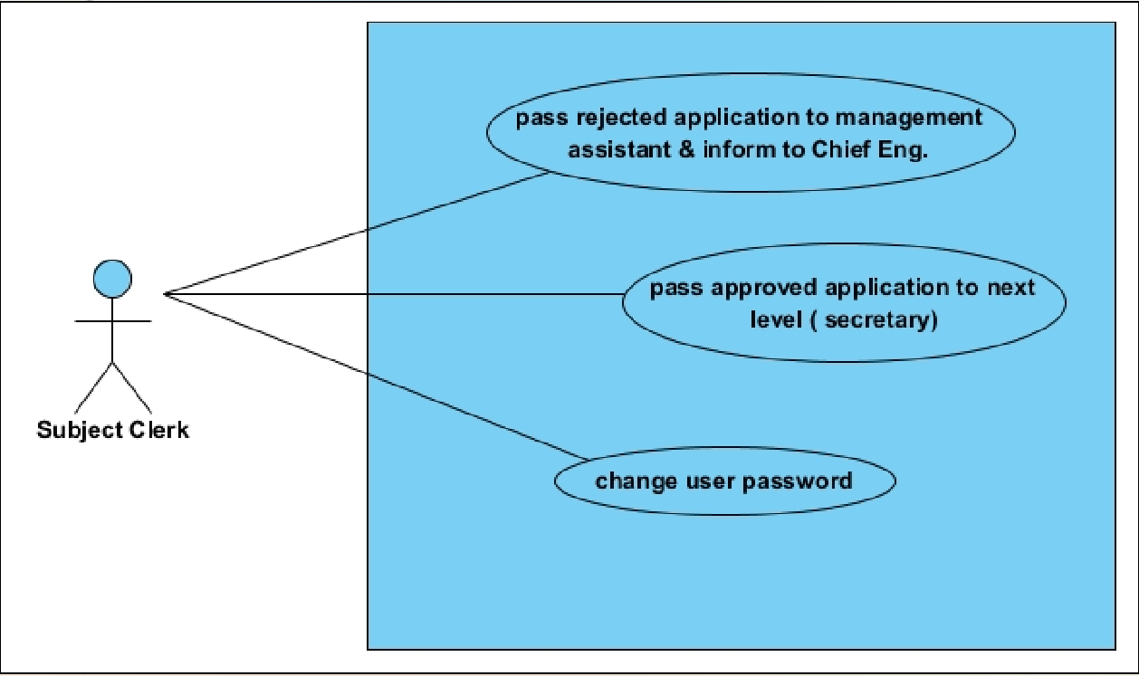

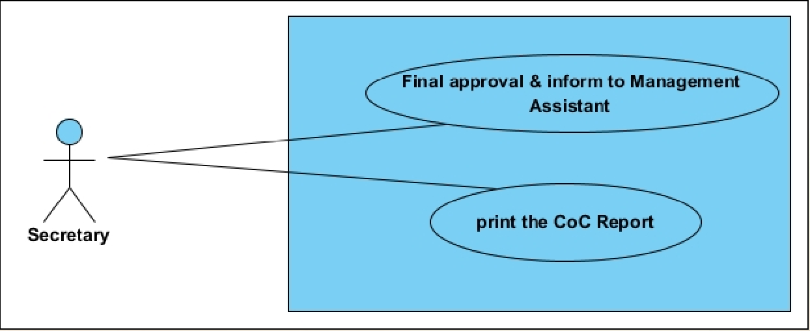

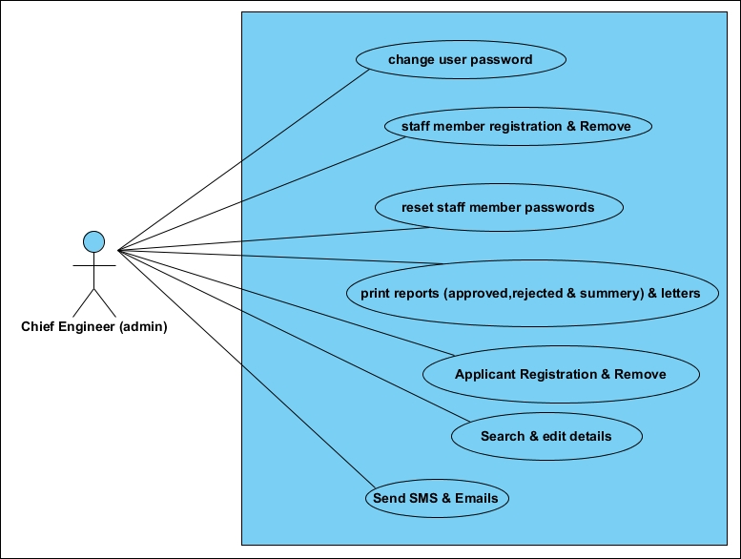

* **Use Case Diagram**

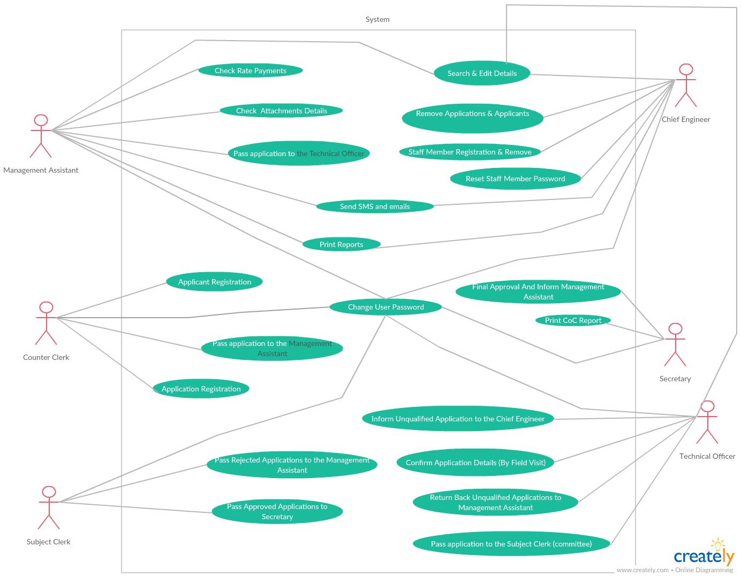

* **Use cases**
* Use Cases related to the Counter Clerk

➢ Use Case 1 : ​Applicant Registration & Passing to next level

○ ​Primary Actor : ​Counter Clerk

○ PreCondition : ​Counter Clerk should be Logged in

○ Main Scenario​ :

■ Go to the Counter Clerk’s Main GUI

■ Click on the Button , “Applicant Registration”

■ The system will ask to, type the informations which is related to basic personal & contact details of the Applicant.

■ The Counter Clerk should provide all details using the Application which was given by the applicant.

■ Click on the Button, ”Submit”.

■ ​The system will ask from the Counter Clerk to select the next level Actor.

■ System does the Authentication.

■ ​Store registration details in the system database/update database.

○ Alternate Scenario :

■ Counter Clerk does not provide the Details for some main Fields

● Prompt the Counter Clerk​ ​that he hasn’t Filled the fields properly.

● Highlight those fields,Allow the Counter Clerk to re-fill those remaining fields.

■ The entered Fields are (phone number) not valid

● Prompt the Counter Clerk that he has entered invalid Informations.

● Allow the Counter Clerk to re-enter.

➢ Use Case 2 : ​Change the user Password

○ ​Primary Actor : ​Counter Clerk

○ PreCondition : ​Counter Clerk should be Logged in

○ Main Scenario​ :

■ Click on the Button , “Change User Password”.

■ The System is prompted for current password,new password & confirm the new password.

■ Counter Clerk provides the current password,new password & confirm new password.

■ ​System does authentication.

■ The System stores new password in database.

○ Alternate Scenario :

■ Authorization fails.

● Prompt the Counter Clerk that the typed current password is wrong.

● Allow the Counter Clerk to re-enter the current password,give him 3 Attempts.

■ Confirm password does not match with the new password

● A message is shown to the Counter Clerk saying about that.

● Allow him to re-enter those attributes. Give 3 Attempts.

* Use Cases related to A Management Assistant

➢ Use Case 3 : ​Check Rate Payments & Attachments

○ ​Primary Actor : ​Management Assistant

○ PreCondition : ​Management Assistant should be Logged in.

○ Main Scenario​ :

■ Click on the Button, “View Pendings”.

■ The system will show the pending Application list.

■ Select a Pending Application.

■ Click on the Button, “Show Attachments”.

■ The System will prompt the relevant attachments(Rate payment Receipt,plan etc).

■ Check detail & Set the Rate payment & Attachments state as “OK” by clicking the confirm button.

■ System does Authentication.

■ The system ​ ​stores those details in database/update database.

○ Alternate Scenario :

■ There is no Attachment/Missing Attachments.

● Send SMS or Email to the Relevant Applicant.

■ Attachment/Payment not valid.

● Send SMS or Email to the Relevant Applicant.

➢ Use Case 4 : ​Accept & Pass Applications to next level(Clear Pendings)

○ Primary Actor : ​Management Assistant

○ PreCondition : ​Management Assistant should be Logged in

○ Main Scenario​ :

■ Click on the Button , “View Pendings”

■ The system will show the pending Application list

■ Select a Pending Application

■ Click on the Button , “Accept”

■ The System will ask from the Management Assistant to select the next level Actor

■ System does Authentication

■ the System ​​stores those details in database/update database

○ Alternate Scenario :

■ Missing Attachments / Rate payment not Valid.

● Prompt the Management Assistant by a message.

➢ Use Case 5 : ​Check Queries / Search Details

○ Primary Actor : ​Management Assistant

○ PreCondition : ​Management Assistant should be Logged in

○ Main Scenario​ :

■ Click on the Button, “Get Details”

■ The system will show a new window to enter id/regNo for search details

■ Click on the Button, “Search”

■ System does Authentication

■ the System will show a new window with full details.(with current status & comments)

■ (can be send some messages through this window)

■ (can be update applicant details through this window) ○ Alternate Scenario :

■ File/Application not Found

● Prompt the Management Assistant by a message.

➢ Use Case 6 : ​Print Daily Reports

○ Primary Actor : ​Management Assistant

○ PreCondition : ​Management Assistant should be Logged in

○ Main Scenario​ :

■ Click on the Button , “Print Reports”.

■ The system will show a new window to Select a Report type,Time Period etc.

■ Click on the Button , “Print”.

■ System does Authentication.

➢ Use Case 7 : ​Print Letters

○ Primary Actor : ​Management Assistant

○ PreCondition : ​Management Assistant should be Logged in

○ Main Scenario​ :

■ Click on the Button , “Print Letters”.

■ The system will show a new window to Select a LetterHead, sender Address,content etc.

■ Click on the Button , “Print”.

■ System does Authentication.

○ Alternate Scenario :

■ Management Assistant does not provide the Details for some main Fields.

● Prompt the Management Assistant that he hasn’t Filled the fields properly.

● Highlight those fields,Allow the Management Assistant to re-fill those remaining fields .

➢ Use Case 8 : ​Send SMS & Emails

○ Primary Actor : ​Management Assistant

○ PreCondition : ​Management Assistant should be Logged in

○ Main Scenario​ :

■ Click on the Button , “SMS & Emails”.

■ The system will show a new window to Select the Mode(sms/email),phone number/email,content etc.

■ Click on the Button , “Send”.

■ System does Authentication.

○ Alternate Scenario :

■ Management Assistant does not provide the Details for some main Fields.

● Prompt the Management Assistant that he hasn’t Filled the fields properly.

● Highlight those fields,Allow the Management Assistant to re-fill those remaining fields.

■ Invalid phone number/Email

● Prompt the Management Assistant that he hasn’t entered an invalid phone number / email.

● Allow the Management Assistant to re-fill that field.

➢ Use Case 9 : ​Change the User Password.

○ Primary Actor : ​Management Assistant

○ PreCondition : ​Management Assistant should be Logged in.

○ Main Scenario​ :

■ Click on the Button, “Change User Password”

■ The System is prompted for current password,new password & confirm the new password.

■ Management Assistant should provide the current password,new password & confirm new password.

■ ​System does Authentication.

■ The system ​stores new password in Database

○ Alternate Scenario :

■ Authorization fails

● Prompt the Management Assistant that the typed current password is wrong.

● Allow the Management Assistant to re-enter the current password,give him 3 chances.

■ confirm password does not match with the new password

● A message is shown to the Management Assistant saying about that.

● Allow him to re-enter those attributes. Give 3 chances

* Use Cases related to A Technical Officer

➢ Use Case 10 : ​Confirm Application Details

○ Primary Actor : ​Technical Officer

○ PreCondition : ​Technical Officer should be Logged in

○ Main Scenario​ :

■ Click on the Button , “View Pendings”

■ The system will show the pending Application list

■ Select a Pending Application

■ Click on the Button , “Set Details”

■ The system will show a new window to fill Related Details.

■ Technical Officer should provide those Details.

■ Click on the Button , “OK”

■ ​System does authentication.

■ System will Automatically Reject applications which are does not meet the minimum requirements & pass those Applications to Rejected List.

■ The system ​ ​stores those details in database/update database ○ Alternate Scenario :

■ Technical Officer does not provide the Details for some main Fields

● Prompt the Technical Officer​ ​that he hasn’t Filled the fields properly

● Highlight those fields,Allow the Technical Officer to re-fill those remaining fields

➢ Use Case 11 :​Accept & Pass Applications to next level(Clear Pendings)

○ Primary Actor : ​Technical Officer

○ PreCondition : ​Technical Officer should be Logged in.

○ Main Scenario​ :

■ Click on the Button , “View Pendings”.

■ The system will show the pending Application list.

■ Select a Pending Application.

■ Click on the Button , “Accept” .

■ System does Authentication.

■ The system ​ ​stores those details in database/update database.

➢ Use Case 12 : ​Reject Applications / inform to Chief Eng.

○ Primary Actor : ​Technical Officer

○ PreCondition : ​Technical Officer should be Logged in

○ Main Scenario​ :

■ Click on the Button , “Rejected List”

■ The System will show the Rejected Application list.

■ Select a Reject Application.

■ Click on the Button , “Send to Chief Eng”.

■ The system will show a new window to give comments & arguments.

■ Click on the Button , “send”.

■ System does Authentication.

■ The system ​ ​stores those details in database/update database

○ Alternate Scenario :

■ Technical Officer does not provide his comment

● Prompt the Technical Officer​ ​that he hasn’t commented on the Application.

● Allow the Technical Officer to re-comment.

➢ Use Case 13 : ​Change the user Password

○ Primary Actor : ​Technical Officer

○ PreCondition : ​Technical Officer should be Logged in

○ Main Scenario​ :

■ Click on the Button , “Change User Password”.

■ The System is prompted for current password,new password & confirm the new Password.

■ Technical Officer should provide the current password,new password & confirm new password.

■ ​System does authentication.

■ The system ​ ​stores new password in Database.

○ Alternate Scenario :

■ Authorization fails

● Prompt the Technical Officer that the typed current password is wrong.

● Allow the Technical Officer to re-enter the current password,give him 3 Attempts.

■ confirm password does not match with the new password

●A message is shown to the Technical Officer saying about that.

● Allow him to re-enter those attributes. Give 3 Attempts.

* Use Cases related to the Subject Clerk

➢ Use Case 14 : ​Confirm & pass Applications

○ Primary Actor : ​Subject Clerk

○ PreCondition : ​Subject Clerk should be Logged in

○ Main Scenario​ :

■ Click on the Button , “View Pendings”.

■ The system will show the pending Application list.

■ Select a Pending Application.

■ Click on the Button , “Set Details”

■ The system will show a new window to fill Related Details.

■ Subject Clerk should provide those Details.

■ Click on the Button , “OK” .

■ Or , Subject Clerk can Reject applications which rejected by the committee & pass those Applications to Rejected List.

■ ​System does authentication.

■ The system ​ ​stores those details in database/update database.

○ Alternate Scenario :

■ Subject Clerk does not provide the Details for some main Fields

● Prompt the Subject Clerk​ ​that he hasn’t Filled the fields properly.

● Highlight those fields,Allow the Subject Clerk to re-fill those remaining fields.

➢ Use Case 15 : ​Reject Applications

○ Primary Actor : ​Subject Clerk

○ PreCondition : ​Subject Clerk should be Logged in

○ Main Scenario​ :

■ Click on the Button , “Rejected List”.

■ The system will show the Rejected Application list.

■ Select a Reject Application.

■ Click on the Button , “Send to Chief Eng”.

■ The system will show a new window to give comments & arguments.

■ Click on the Button , “send”.

■ System does Authentication.

■ The system ​ ​stores those details in database/update database.

○ Alternate Scenario :

■ Subject Clerk does not provide his comment

● Prompt the Subject Clerk​ ​that he hasn’t commented on the application.

● Allow him to re-comment.

➢ Use Case 16 : ​Change the user Password

○ Primary Actor : ​Subject Clerk

○ PreCondition : ​Subject Clerk should be Logged in.

○ Main Scenario​ :

■ Click on the Button , “Change User Password”.

■ The System is prompted for current password,new password & confirm the new password.

■ Subject Clerk should provide the current password,new password & confirm new password.

■ ​System does authentication.

■ The system ​ ​stores new password in database.

○ Alternate Scenario :

■ Authorization fails

● Prompt the Subject Clerk that the typed current password is wrong.

● Allow the Subject Clerk to re-enter the current password,give him 3 chances.

■ Confirm password does not match with the new password.

● A message is shown to the Subject Clerk saying about that.

● Allow him to re-enter those attributes. Give 3 Attempts.

* Use Cases related to the Secretary

➢ Use Case 17 : ​Final Approve

○ Primary Actor : ​Secretary

○ PreCondition : ​Secretary should be Logged in

○ Main Scenario​ :

■ Click on the Button , “Final Approve”.

■ The system will show the pending Application list.

■ Select a Pending Application.

■ Click on the Button , “Set Approving Details”.

■ The System will show a new window to fill related

details(Authorising code & etc.).

■ Secretary should provide those Details.

■ Click on the Button , “OK” .

■ Application will put to the Approved List.

■ System does authentication.

■ The system ​ ​stores those details in database/update database.

○ Alternate Scenario :

■ Secretary does not provide the Details for some main Fields.

● Prompt the Secretary that that he hasn’t Filled the fields properly.

➢ Use Case 18 : ​print the CoC Report

○ Primary Actor : ​Secretary

○ PreCondition : ​Secretary should be Logged in

○ Main Scenario​ :

■ Click on the Button , “Print CoC” .

■ The System will show the Approved Application list.

■ Select a Approved Application.

■ Click on the Button , “Print ” .

➢ Use Case 19 : ​Change the user Password

○ Primary Actor : ​Secretary

○ PreCondition : ​Secretary should be Logged in

○ Main Scenario​ :

■ Click on the Button , “Change User Password” .

■ The System is prompted for current password,new password & confirm the new password.

■ Secretary should provide the current password,new password & confirm new password.

■ ​System does authentication.

■ The system ​ ​stores new password in Database.

○ Alternate Scenario :

■ Authorization fails

● Prompt the Secretary that the typed current password is wrong.

● Allow the Secretary to re-enter the current password,give him 3 Attempts.

■ Confirm password does not match with the new password

● A message is shown to the Secretary saying about that.

● Allow him to re-enter those attributes.give 3 chances

* Use Cases related to the Chief Engineer / Admin

➢ Use Case 20 : ​Member Registration

○ Primary Actor : ​Chief Engineer

○ PreCondition : ​Chief Engineer should be Logged in

○ Main Scenario​ :

■ Click on the Button , “User registration”

■ The system will show a new window to select user type(TO,Counter Clerk & etc) & fill other Relevant user Details.

■ Click on the Button , “Register”.

■ System does authentication.

■ (New User will Register with default password).

■ The system ​ ​stores those details in database/update database.

○ Alternate Scenario :

■ Chief Engineer does not provide the Details for some main Fields.

● Prompt the Chief Engineer​ ​that he hasn’t Filled the fields properly.

● Highlight those fields,Allow the Chief Engineer to re-fill those remaining fields.

➢ Use Case 21 : ​Member Removal

○ Primary Actor : ​Chief Engineer

○ PreCondition : ​Chief Engineer should be Logged in

○ Main Scenario​ :

■ Click on the Button , “User registration”.

■ The System will show the list of Users.

■ Select the user.

■ Click on the Button , “Remove” .

■ The System will show a confirm dialog box.

■ Click on the Button , “Confirm”.

■ System does authentication.

■ The system ​ ​will update the database.

○ Alternate Scenario :

■ Authorization fails,

● Prompt the Chief Engineer that the member is the only one member who left in his type.

➢ Use Case 22 : ​Reset Member Password

○ Primary Actor : ​Chief Engineer

○ PreCondition : ​Chief Engineer should be Logged in

○ Main Scenario​ : ■ Click on the Button , “reset member password” .

■ The System will show the list of users .

■ Select the user.

■ Click on the Button , “Reset password”.

■ The System will show a confirm dialog box.

■ Click on the Button , “Confirm”.

■ System does authentication.

■ The system ​ ​stores the Default password as his user password in the database.

➢ Use Case 23 : ​Applicant Registration & (Passing to next level)

○ Primary Actor : ​Chief Engineer.

○ PreCondition : ​Chief Engineer should be Logged in.

○ Main Scenario​ : ■ Click on the Button , “Applicant Registration” .

■ The system will ask to type the informations which is related to basic personal & contact details of the Applicant.

■ The Chief Engineer should provide all details using the Application which was given by the applicant.

■ Click on the Button , Submit.

■ ​The system will ask from the Chief Engineer to select the next level Actor.

■ System does Authentication.

■ ​Store registration details in the system database / update database.

○ Alternate Scenario :

■ Chief Engineer does not provide the Details for some main Fields

● Prompt the Chief engineer​ ​that he hasn’t Filled the fields properly.

● Highlight those fields,Allow the Chief engineer to re-fill those remaining fields.

■ The entered Fields are (phone number) not valid

● Prompt the Chief engineer that he has entered invalid Informations.

● Allow the Chief engineer to re-enter the phone number.

➢ Use Case 24 : ​Remove Applicant

○ Primary Actor : ​Chief Engineer

○ PreCondition : ​Chief Engineer should be Logged in

○ Main Scenario​ :

■ Click on the Button , “Remove Applicant”.

■ The system will show a new window to enter id/regNo (or any other search details)for search details.

■ Click on the Button , “Search”.

■ System does Authentication.

■ System will show selected Applicant(s) via new window.

■ Select the applicant.

■ Click on the Button , “Remove” .

■ The System will show a confirm dialog box

■ Click on the Button , “Confirm” System does authentication.

■ The system ​ ​will update the database.

○ Alternate Scenario :

■ Authorization fails

● Prompt the Chief Engineer that the typed id/regNo (or other details) is incorrect.

● Allow the Chief Engineer to re-ente.r

■ Applicant not found

● Prompt the Chief Engineer that there are no applicant(s) related to the given information.

➢ Use Case 25 : ​Print Daily Reports

○ Primary Actor : ​Chief Engineer

○ PreCondition : ​Chief Engineer should be Logged in

○ Main Scenario​ :

■ Click on the Button , “Print Reports”

■ The system will show a new window to Select a Report type,Time Period etc.

■ Click on the Button , “Print”.

■ System does Authentication.

➢ Use Case 26 : ​Print Letters

○ Primary Actor : ​Chief Engineer

○ PreCondition : ​Chief Engineer should be Logged in

○ Main Scenario​ :

■ Click on the Button , “Print Letters”

■ The system will show a new window to Select a LetterHead, sender Address,content etc.

■ Click on the Button , “Print” .

■ System does Authentication.

○ Alternate Scenario :

■ Chief Engineer does not provide the Details for some main Fields .

● Prompt the Chief Engineer that he hasn’t Filled the fields properly .

● Highlight those fields,Allow the Chief Engineer to re-fill those remaining fields.

➢ Use Case 27 : ​Send SMS & Emails

○ Primary Actor : ​Chief Engineer

○ PreCondition : ​Chief Engineer should be Logged in

○ Main Scenario​ :

■ Click on the Button , “SMS & Emails”

■ The system will show a new window to Select the Mode(SMS/email),phone number/email,content etc.

■ (Can be select a application details from rejected application list)

■ Click on the Button , “Send”

■ System does Authentication

○ Alternate Scenario :

■ Chief Engineer does not provide the Details for some main Fields

● Prompt the Chief Engineer that he hasn’t Filled the fields properly

● Highlight those fields,Allow the Chief Engineer to re-fill those remaining fields

➢ Use Case 28 : ​Search Details & Edit

○ Primary Actor : ​Chief Engineer

○ PreCondition : ​Chief Engineer should be Logged in

○ Main Scenario​ :

■ Click on the Button , “Get & edit Details”

■ The system will show a new window to enter id/regNo for search details

■ Click on the Button , “Search”

■ System does Authentication

■ The System will show a new window with full details.(with current status & comments)

■ (Can be edit details and re-attach attachments)

■ (Can be send some messages through this window)

■ (Can be update applicant details through this window)

○ Alternate Scenario :

■ File/Application not Found

● Prompt the Chief Engineer by a message.

➢ Use Case 29 : ​Change the user Password

○ Primary Actor : ​Chief Engineer

○ PreCondition : ​Chief Engineer should be Logged in

○ Main Scenario​ :

■ Click on the Button , “Change User Password”

■ The System is prompted for current password,new password & confirm the new password.

■ Chief Engineer should provide the current password,new password & confirm new password.

■ ​System does authentication.

■ The system ​​stores new password in database

○ Alternate Scenario :

■ Authorization fails

● Prompt the Chief Engineer that the typed current password is wrong.

● Allow the Chief Engineer to re-enter the current password,give him 3 Attempts.

■ Confirm password does not match with the new password.

● A message is shown to the Chief Engineer saying about that.

● Allow him to re-enter those attributes. Give 3 attempts.

3.3 Functional and Non Functional Requirements.

**3.3.1.Functional Requirements**

A  **Functional Requirement** defines a **function** of a system or its component. A **function** is described as a set of inputs, the behavior, and outputs.

* Register applicant details.
* Forward relevant documents to the next level.
  + Counter clerk Management Assistant
  + Management Assistant Technical Officer
  + Technical Officer Subject Clerk
  + Technical Officer Chief Engineer
  + Subject Clerk Secretary
* Handle inquiries.
* Update details.
* Print “Certificate of Conformity” (CoC).
* Send an e-mail / SMS to the applicant.
* Daily and Monthly reports(How many applications were rejected and qualified during time period).
* Rejection or approval notification for end of the each stage.

We can describe the Functional requirements by giving various use Cases.

**3.3.2. Non Functional Requirements.**

Non-functional requirements describe the behavior of the system other than the main functionalities of it. Hence, they will cover the requirements which are not included in functional requirements. Non-functional requirements describe the usability, reliability, performance, maintainability and other similar aspects of the system. These set of requirements may not be directly related to the main functionality but they are of extreme importance to the proper functioning of the system.

* **Security : -**

Should be able to provide the safety and security of the System. Since people including Staff and the Applicants wants to keep their personal details confidentially, the system should be secured without unauthorized access.

* **Reliability : -**
* Should be able to recover data from unexpected power failures and system crashes.

In order to keep continuous flow of data usage system should be able to recover data from unexpected power failures and system crashes.

* The system shall keep a log of all the errors
* **Maintainability : -**
* System must be able to handle larger sets of data efficiently in many cases.
* System can be extended in future. (According to client need and modern technology).
* **User Friendliness : -**
* Should be able to present a more attractive user-friendly interface.
* Usability and understandability of the interfaces should be accordance with the standards.
* **Disaster Recovery : -**
* The system should be able to take a copy of its database (backup) and store it in a different place. Most often this backup copy is stored at a location in another building.
* **Free and Open Source Software : -**
* The system should operate on a server running a free & open source operating system. Furthermore, all other required software must also be free & open source.

1. **Proposed System’s Architecture**

**4.1 Software Structure**

The software structure of PMS was develop to automate the Urban Council proceedings to help the Applicant, and staff including Engineer and Secretary.

The structure is shown in below figure and descriptions of the modules can be presented as follows.

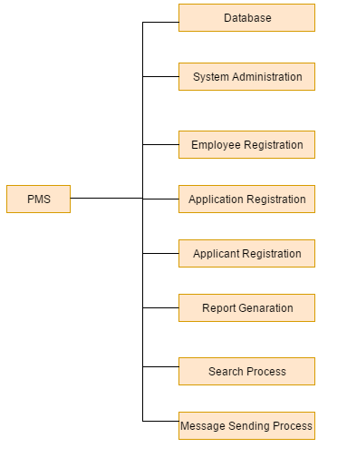

4.2 **Components & Their Responsibilities**

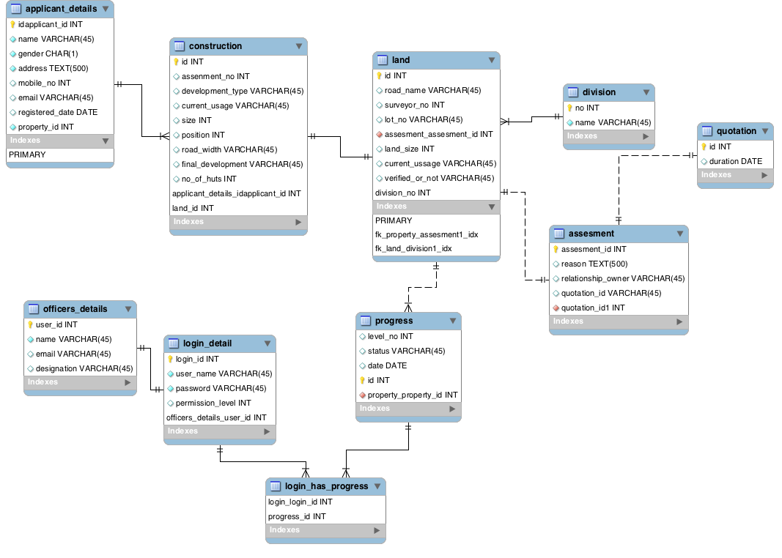

4.3 **Component Interactions**

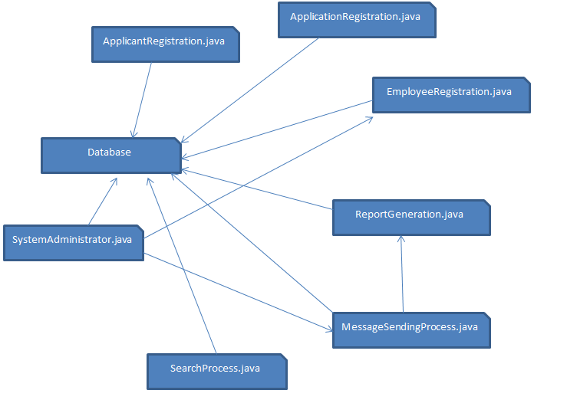

4.4  **System Architecture**

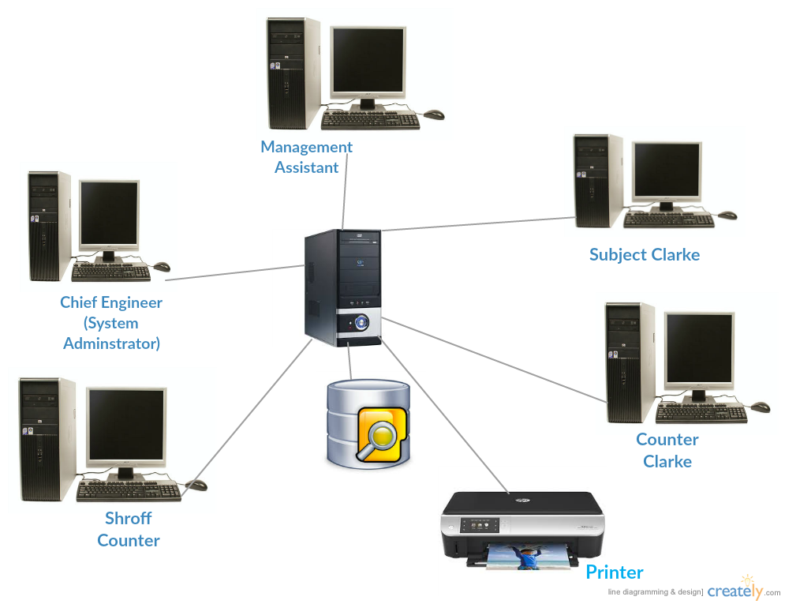

This above image shows the design on system architecture. We planned to establish a LAN (Local Area Network) which may connect several host computers to a centralized server. There will be a Computer for each person in the system with user login ID and a password. All these computers will be connected to a centralized server, so our database would be a centralized database

**System's Design**

* 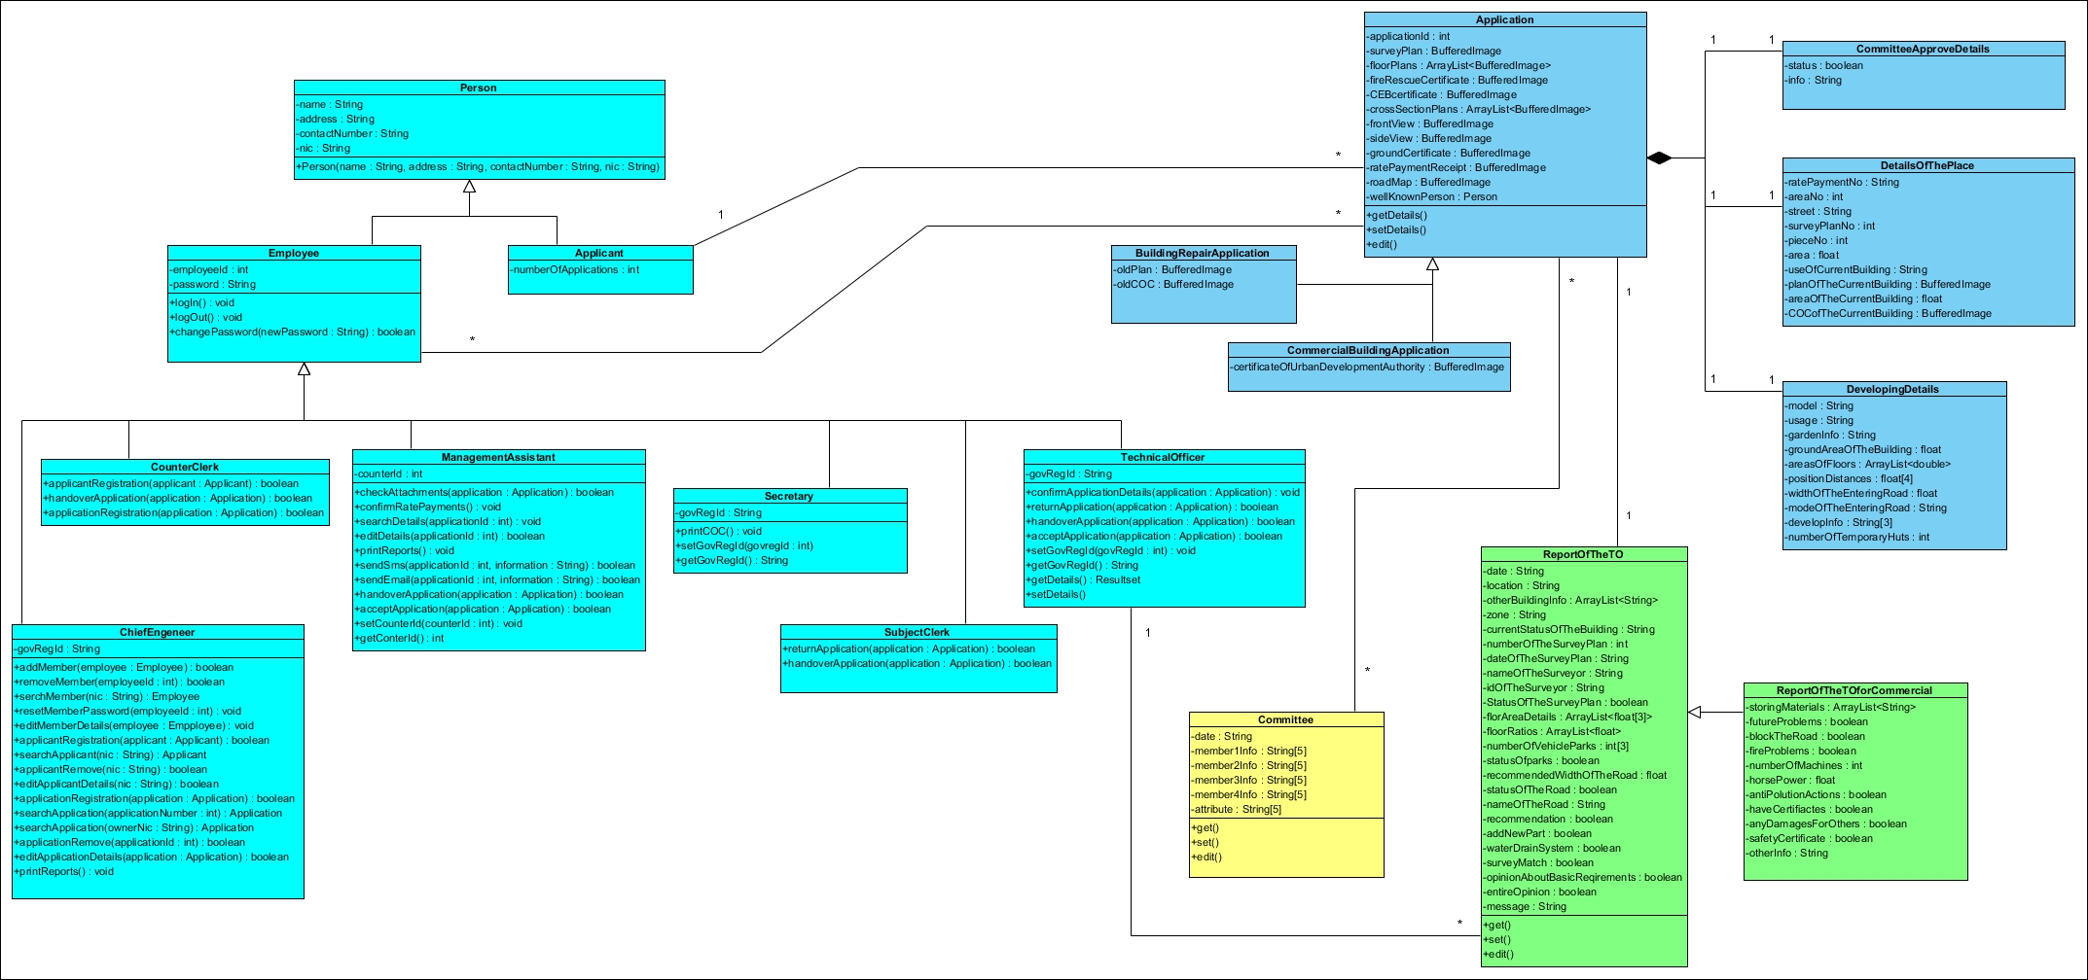**Class Diagram**
* **Sequence Diagrams**

**User Login**

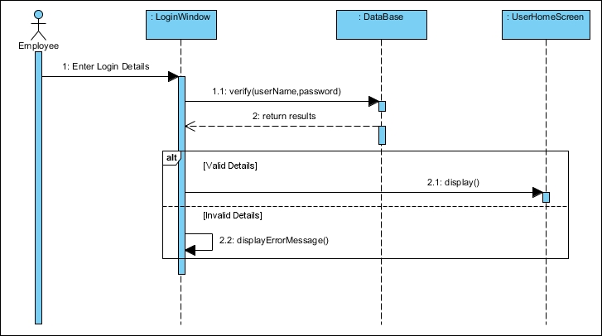

**Applicant Registration**

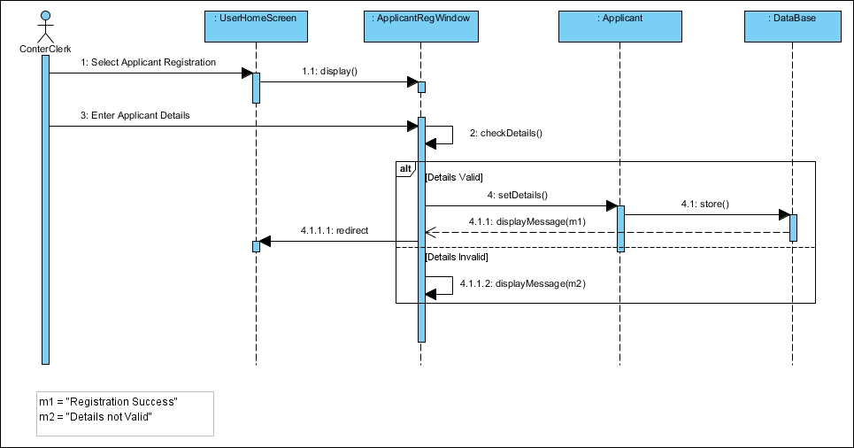

**Application Registration**

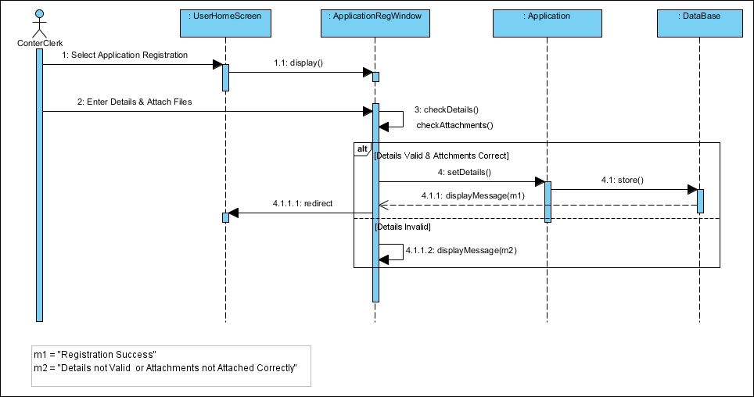

**Employee Registration**

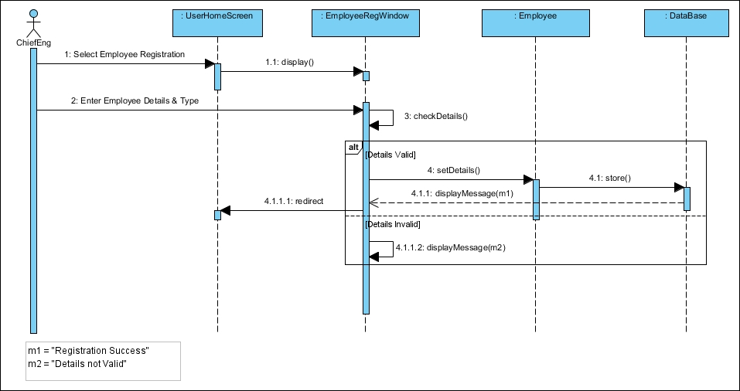

**Remove Employee**

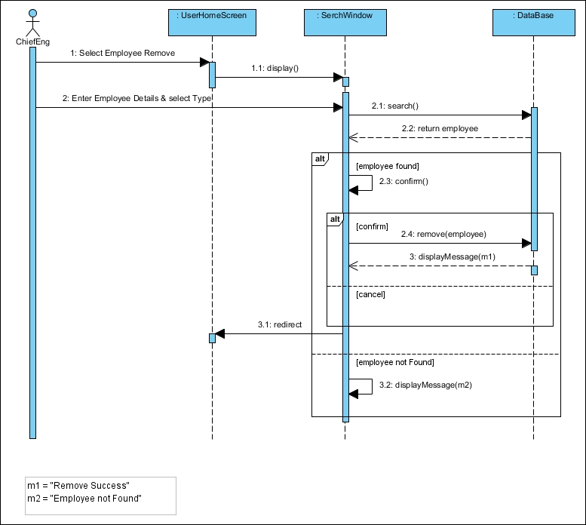

**Change Password**

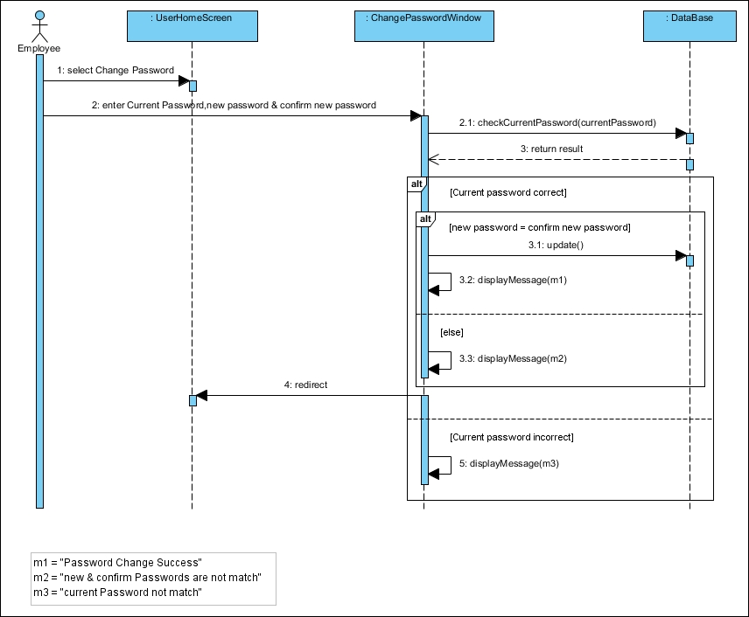

**Print CoC**

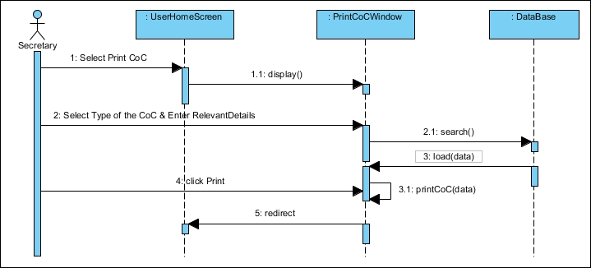

**Print Reports**

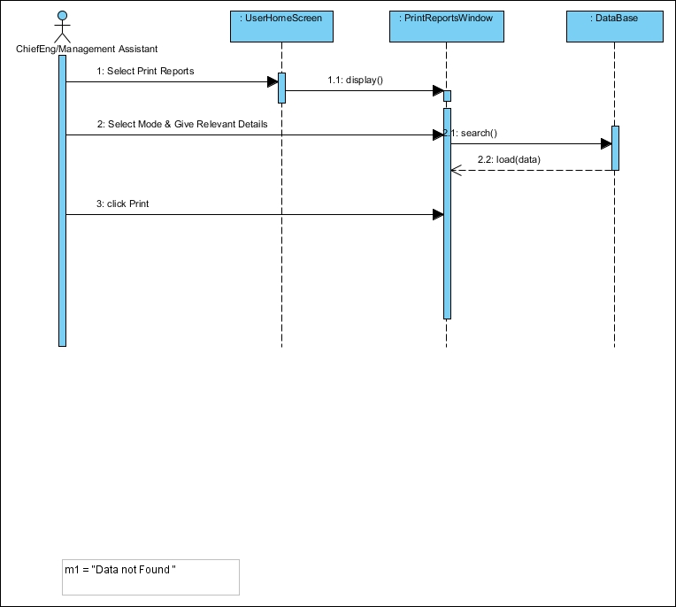

**Send Messages**

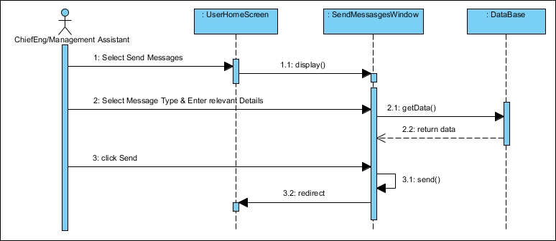

**Search Data**

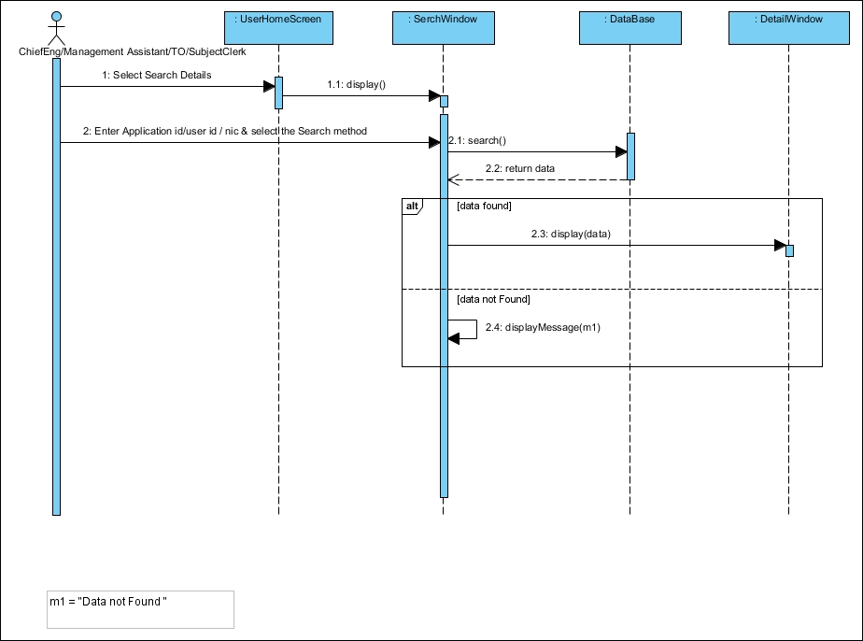

**Reset Password**

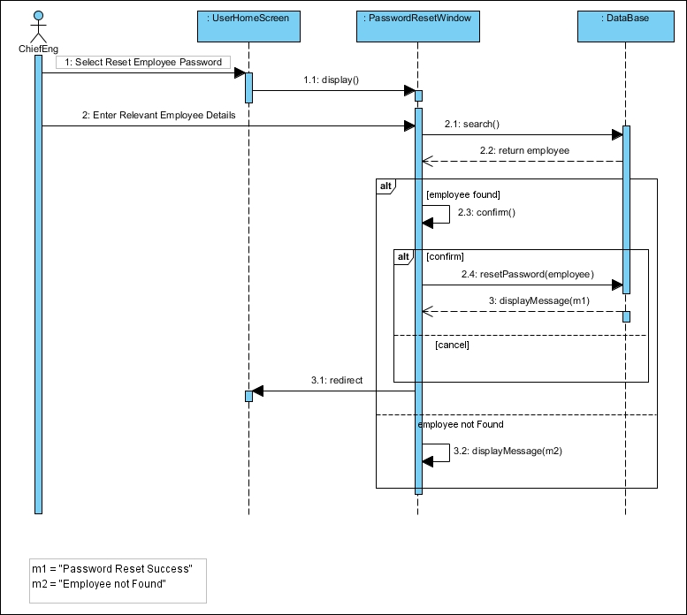

**Remove Applicant**

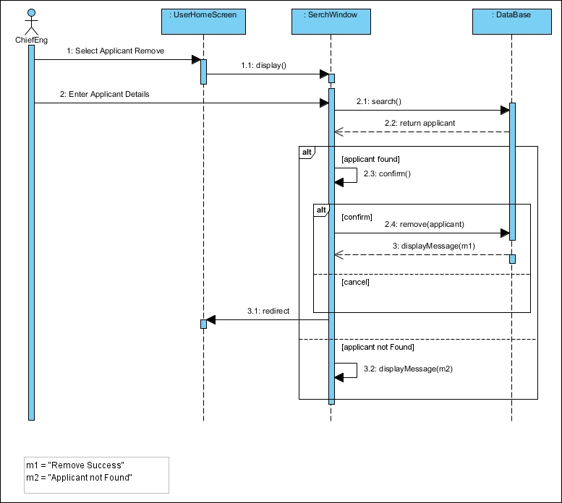

**Remove Application**

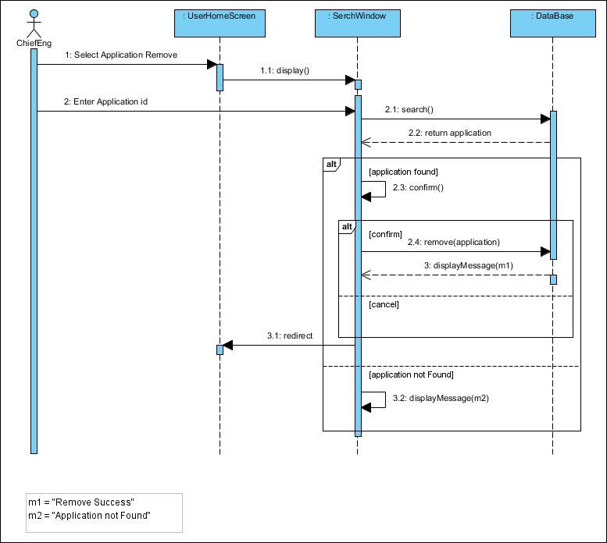

**Remove Employee**

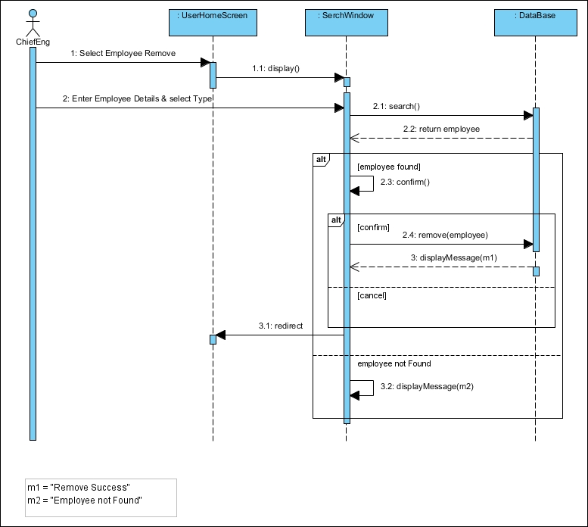

1. **User Interface Flow Diagram**
2. **Counter Clerk**

|  |
| --- |
| 1.1 Find Applicant  1.2 Applicant Registration  1.3 Application Registration |

|  |
| --- |
| 1.1.1. Enter Applicant NIC |

|  |
| --- |
| 1.2.1. Applicant personal details |

|  |
| --- |
| 1.3.1. Related Applicant  1.3.2. Related Division detail  1.3.3. Construction details  1.3.4. No of temporary huts |

2. **Management Assistant**

|  |
| --- |
| 2.1. Check Attachment  2.2. Search Details  2.3. Edit Details  2.4. Print Reports  2.5. Send Messages to Applicant  2.6. Return Application |

|  |
| --- |
| 2.1.1. Rate Payment Details  2.1.2. Documents of the Plan  2.1.3. Report of Central Environment Authority (If necessary)  2.1.4. Report of Labour Department (If necessary)  2.1.5. Report of Fire Brigade (If necessary)  2.1.6. Sketch of the Road Map  2.1.7. Architecture’s Report |

|  |
| --- |
| 2.2.1. Search Method (Applicant- NIC , Application- Application ID) |

|  |
| --- |
| 2.3.1. Edit Details |

|  |
| --- |
| 2.4.1. Print Daily Reports  2.4.2. Print Monthly Reports |

|  |
| --- |
| 2.5.1. Send SMS  2.5.2. Send E-mail |

|  |
| --- |
| 2.6.1. Application Return Party |

**3. Technical Officer**

|  |
| --- |
| 3.1. Confirm Application Details  3.2. Return Application |

|  |
| --- |
| 3.1.0.The Date Application Received  3.1.1. Application ID  3.1.2. The Date of Application Given  3.1.3. Applicant Details  3.1.4. Place Details  3.1.5. Building Details  3.1.6. Nature of the Building  3.1.7. Use of the Building  3.1.8. Land Details  3.1.9. Ratios of the Floors  3.1.10.Parking Details  3.1.11.Entrance Details  3.1.12.Suitability of the Development  3.1.13.Details of Existing Building  3.1.14.Drainage Details  3.1.15.Tunnel and Drainage Details  3.1.16.Building Background Details  3.1.17.Store Rooms Details  3.1.18.Store or Industry Details (If necessary)  3.1.19.Relevant Certificates Details  3.1.20.Effect to other Buildings  3.1.21.Effects of Development Change Details  3.1.22.Other Details |

|  |
| --- |
| 3.2.1. Application Return Party |

**4. Subject Clerk**

|  |
| --- |
| 4.1. Add Suggestions  4.2. Return Application |

**5. Secretary**

|  |
| --- |
| 5.1. CoC Report |